**Practical No 3**

**Aim :** Execute the LINUX Commands - man, apropos, clear, ls, mkdir, cd, rmdir, pwd, rm, touch, mv, tr, wc, sort, grep, wall, write, who, chmod, useradd, usermod, kill, ssh, ftp, telnet

**Apparatus:** Computer System with Linux Operating System installed in it.

**Theory :**

**What are Linux Commands?**

* The Linux command is a utility of the Linux Operating System.
* All basic and advanced tasks can be done by executing commands.
* The Linux command is a utility of the Linux operating system.
* The commands are executed on the **Linux terminal.**
* The terminal is a command-line interface to interact with the system, which is similar to the command prompt in the Windows OS.
* Commands in Linux are **case-sensitive**

..

**Commands:**

1. **man –** The man command is used to display the user manual of any command. To use this command the user just have to type ‘man’ and next to it the command which you want to see. Syntax : $man [COMMAND NAME]
2. **apropos -** The apropos command is used to find the exact command from the keywords. Syntax :$apropos [keyword]
3. **clear -** The apropos command is used to clear the terminal screen. Syntax : $clear
4. **ls -** The ls command is a command line utility for listing the contents of a directory or directories given to it via standard input. Syntax :$ls
5. **mkdir -** The mkdir command is a command used to create a new directory. Syntax : $mkdir [directory_name]
6. **cd -** The cd command is a command used to change the current working directory in Linux. Syntax: $cd [directory_name] or $cd..
7. **rmdir -** The rmdir command is a command used to remove empty directories from the file system. Syntax : $rmdir directory_name
8. **pwd -** The pwd command is a command used to print the path of the working directory. PWD stands for Print working directory.
9. **rm -** The rm command is a command used to remove objects such as files, symbolic links from the file system. Syntax : $rm [file_name]
10. **touch -** The touch command is a command used to create, change or modify timespan of a file. Syntax : $touch [file_name]
11. **mv -** The mv command is a command used to move one or more files from one location to other. Syntax : $mv [file_name][location]
12. **tr -** The tr command is a command used to translate or delete characters. It is a linux command line utility. Syntax : $tr [set1][set2]
13. **wc -** The wc command is a command used to count number of lines in a given file. Syntax: $wc [file_name]
14. **sort -** The sort command is a command used to arrange records in particular order. Syntax : $sort [file_name]
15. **grep -** The grep command is a command used to search specific string of character in specific file or directory. Syntax : $grep string_name file_name
16. **wall -** The wall command is a command used to send message a message to other users. Syntax : $wall [-n] [-t timeout] [message | file]
17. **write -** The write command is a command used to send message to other users. Syntax : $write user [tty]
18. **who -** The who command is a command used to find time of last boot, logged in users, remote host name of user, run level of system and other information. Syntax : $who [options][filename].
19. **chmod -** The chmod command is a command used to change the mode of access. Syntax : $chmod [reference][operator][mode] file
20. **useradd-** The useradd command is a command used to create a new user or to set the default information for new users**.** Syntax : $useradd [options] username
21. **usermod -** Usermod is a command which has to be executed by the root user. Syntax : $usermod [options] USER
22. **kill -** kill is a command used to terminate a process in Linux. Syntax : [$kill –l]
23. **ssh -** ssh command instructs the system to establish an encrypted secure connection with the host machine. Syntax : $ssh user_name@host(IP/Domain_name)
24. **ftp -** ftp stands for file transfer protocol. The ftp command in Linux is used to perform file transfer to/from a remote network. Syntax : $ftp hostname/IP
25. **telnet -** The telnet command is used to create a remote connection with a system over a TCP/IP network.Syntax : $ telnet ip_address port_number

**Output :**

1. **man –**

$man mkdir

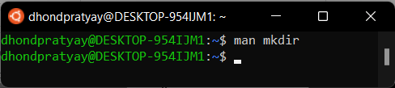

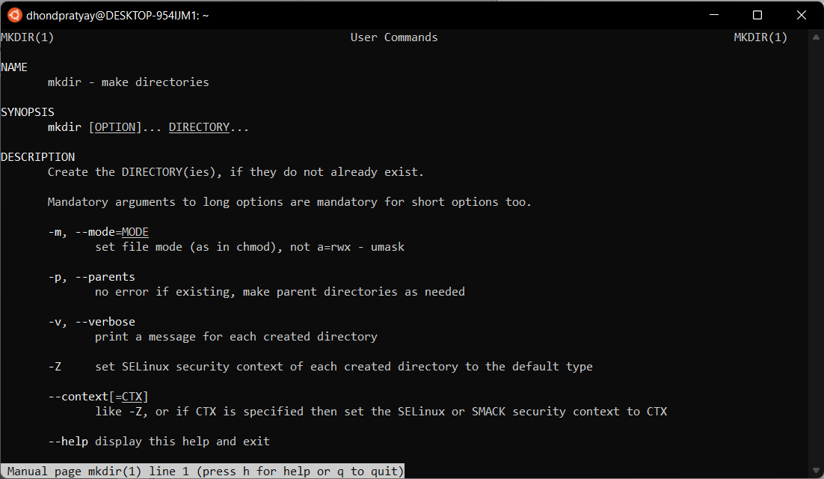

1. **aprospos –**

$aprospos email address

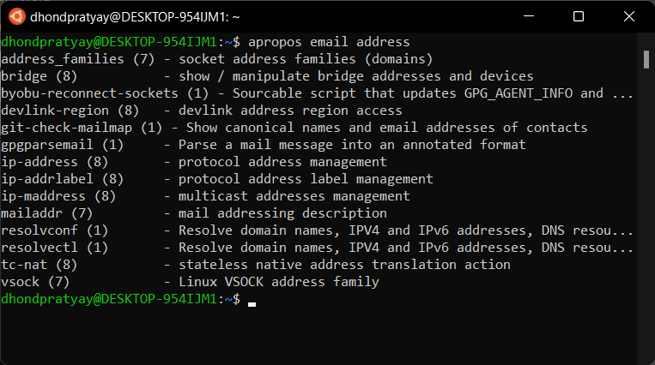

1. **clear –**

$clear

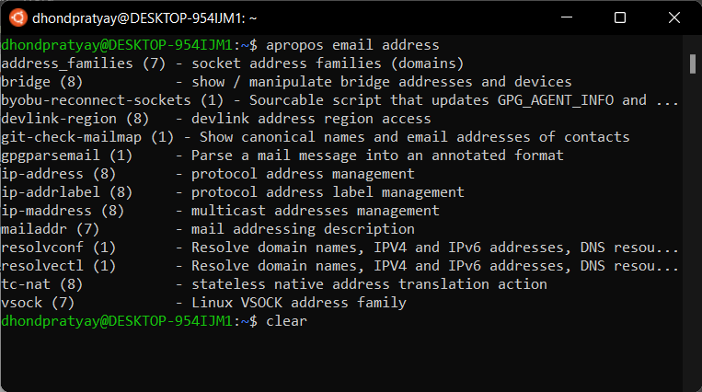 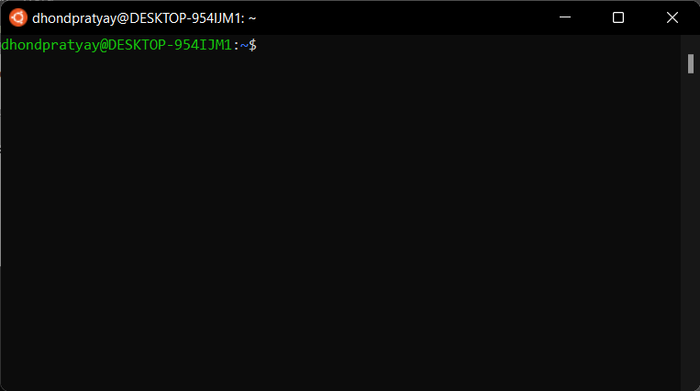

1. **ls –**

$ls

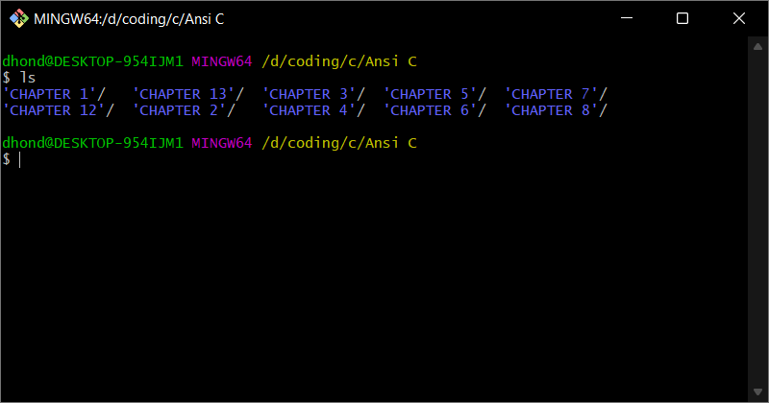

1. **mkdir –**

$mkdir OS

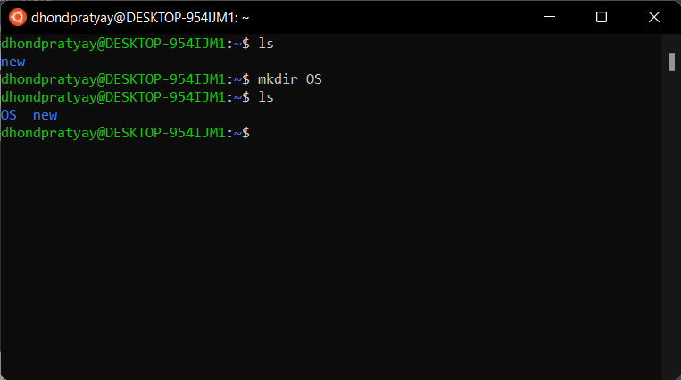

1. **cd –**

$cd OS

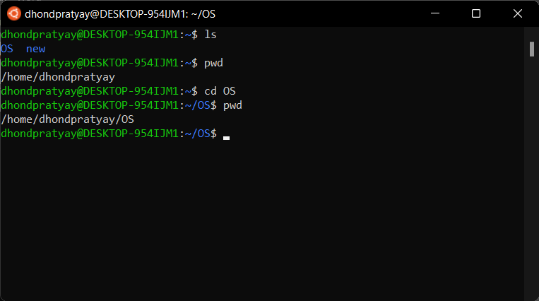

1. **rmdir –**

$rmdir OS

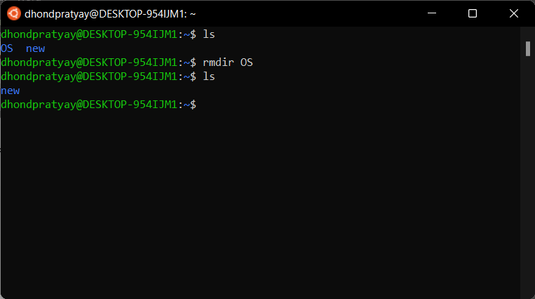

1. **pwd–**

$pwd

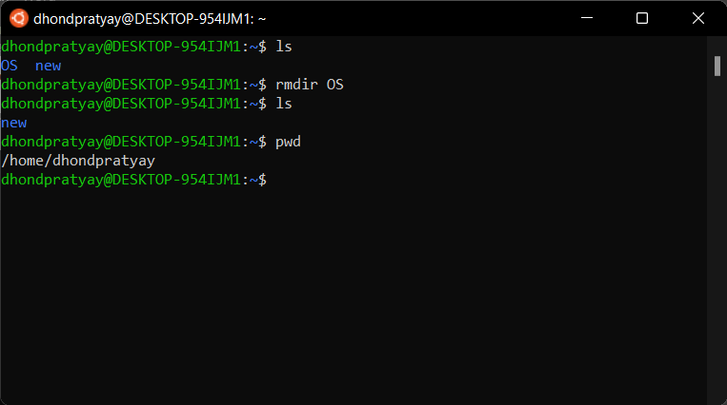

1. **rm –**
2. $rm helloworld.exe

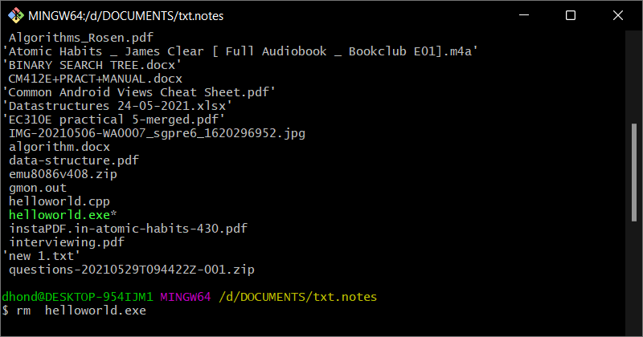

1. **touch –**

$touch --version

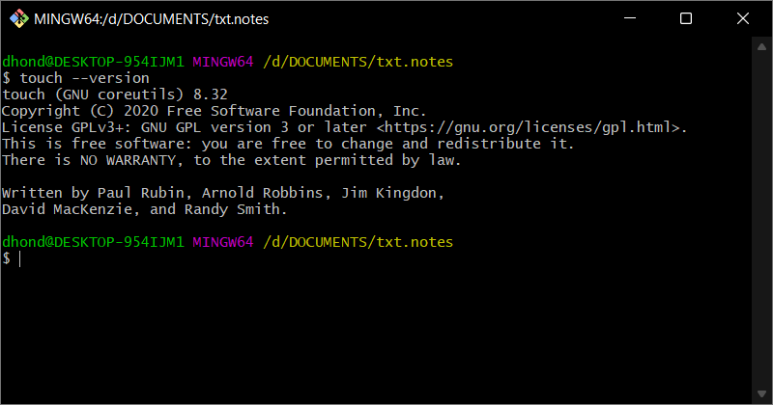

1. **mv –**

$mv mv KandiwaliAdmin/ new

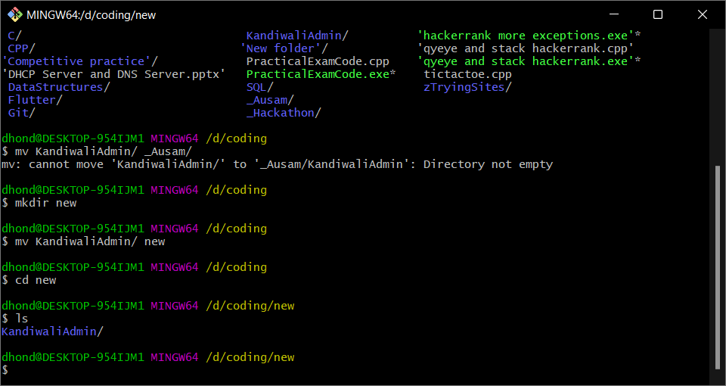

1. **tr –**

$tr –d “hello” < XD.txt

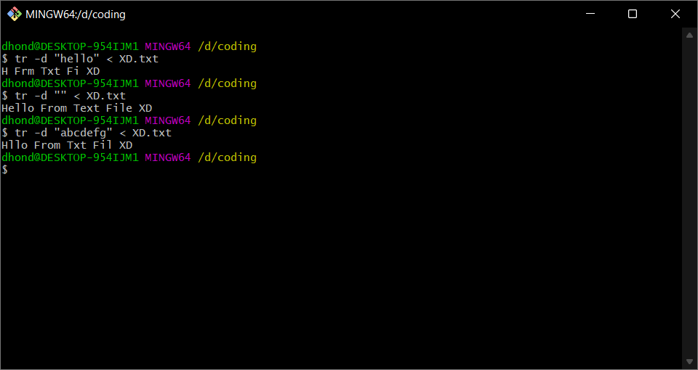

1. **wc –**

$wc ‘Practical No 3.docx’

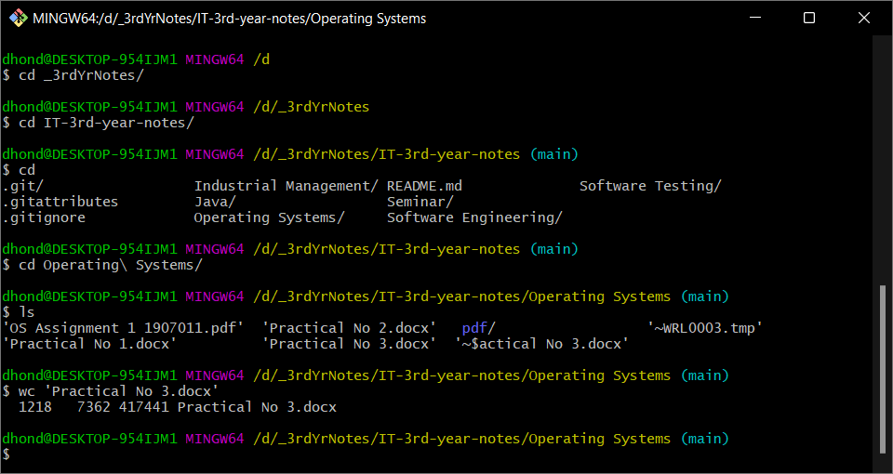

1. **sort –**

$sort sort.txt

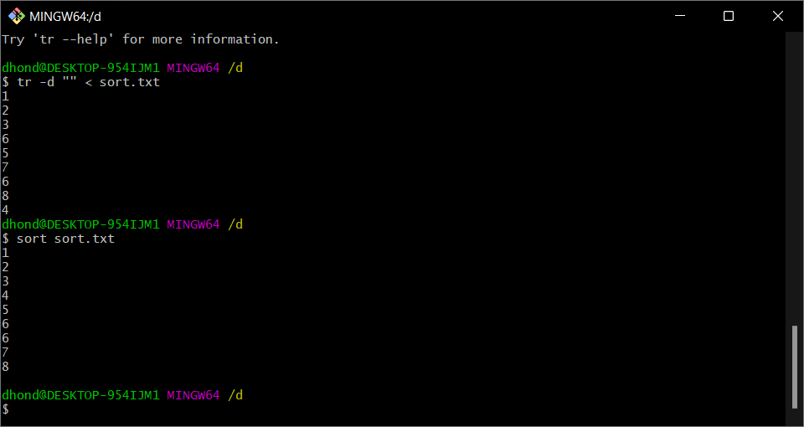

1. **grep –**

$grep –n “untitled” *

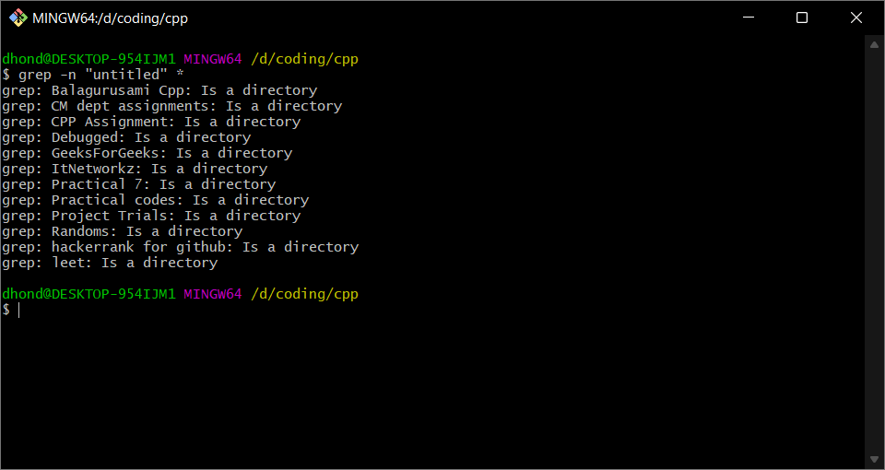

1. **wall –**

$wall “Hello Everyone”

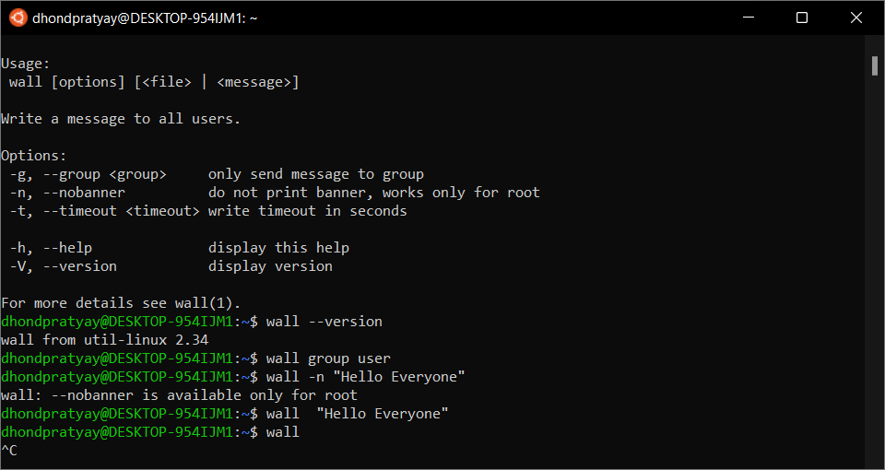

1. **write –**

$write user [tty]

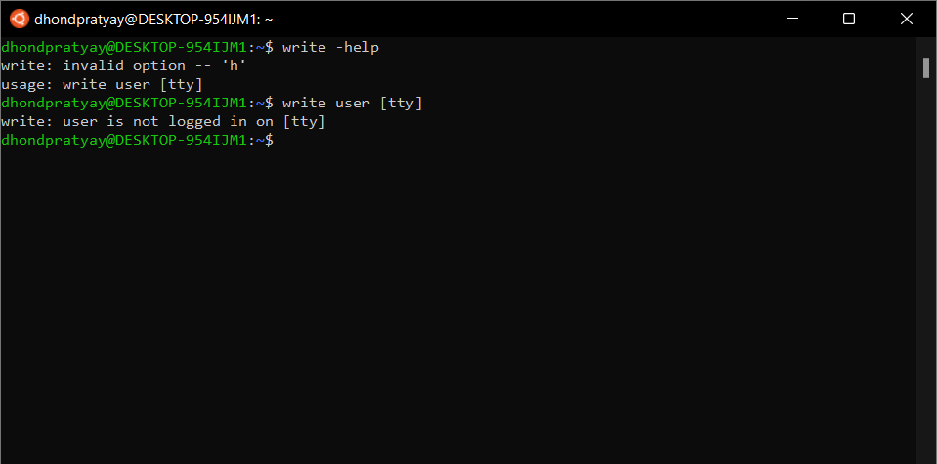

1. **chmod –**

$chmod g=r main.class

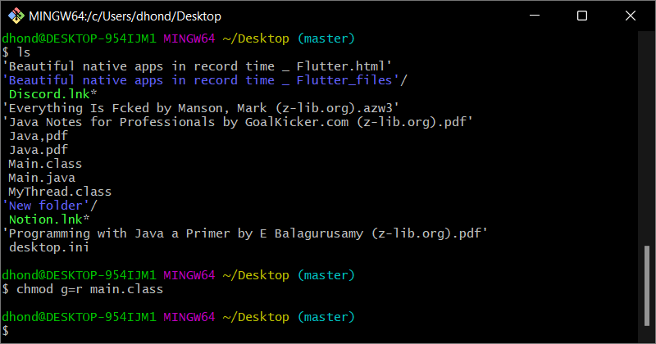

1. **kill –**

$kill -help

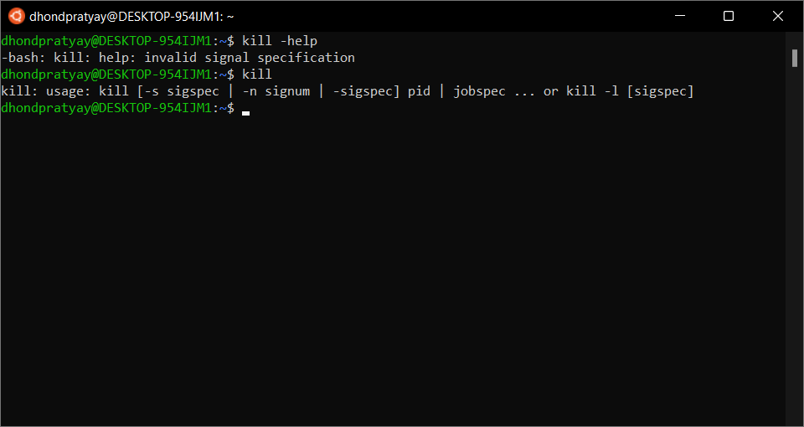

1. **ssh –**

$ssh -help

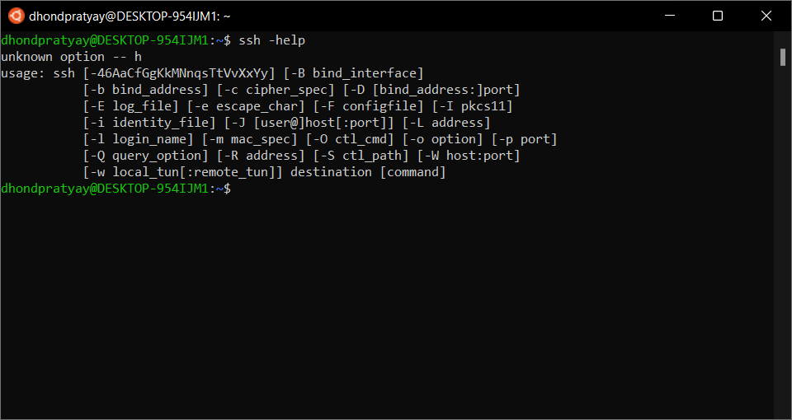

1. **telnet –**

$telnet 192.168.0.1 443

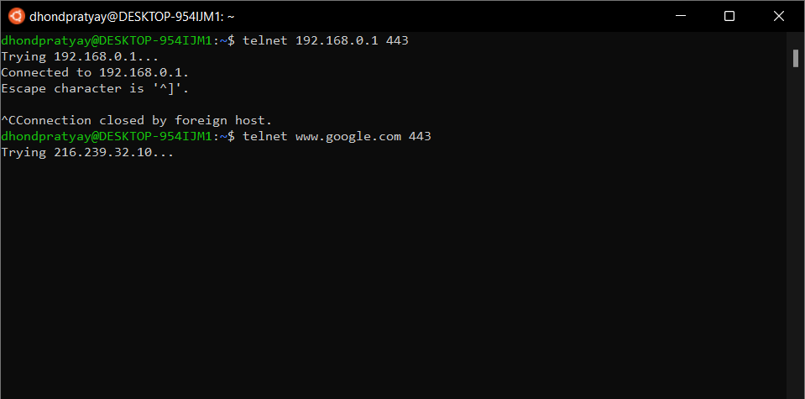

**Conclusion**:

Hence, by performing this practical I got to know about the various commands of the Linux operating system such as man, ls, pwd, wall, write, and various other commands of the Linux operating system which can be executed with the help of the command line interface using shell programming. I also executed the given commands of the Linux operating system using the Linux terminal.